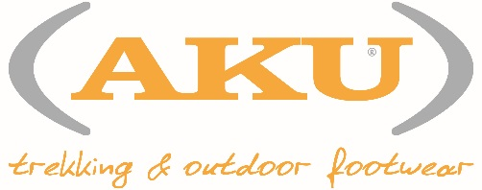

TREK WITH DONKEYS 2016 – How children felt about it…

Enea: “I loved everything!”
Angelica: “I loved it because there was a friend and the donkeys too”
Letizia: “The donkeys were very nice, walking and holding the donkey was fun”
Tommaso: “I loved walking and pull the donkey!”
Astrid: “Thanks for the trek and for the donkeys”
Yago: “A wonderful experience. And the donkeys, woww!!”
Luca: “I was surprised that donkeys walked right besides us”
Mirco: “It was nice to pet the donkeys!”
Eleonora: “Thank you all! I loved walking with the donkeys!”
Vera: “I loved pulling the donkeys. When they took a picture of us it was exciting”
Davide: “The donkeys are fun and I loved the trek, especially seeing all the trees. And the snack was tasty!”
Martina: “Scoprire un bel sentiero in mezzo alla natura, vicino casa, è stato proprio bello! Proprio una simpatica passeggiata in compagnia! Al prossimo anno!”
Nathan: “For me it was the first time to see the donkeys. I think they are very nice! And the snack was very good!”
Thomas: “I was surprised by how calm donkeys were”

…How adults felt about it
Renata: “I liked it because I relived the old times, when I was a child”
Silvio: “It’s nice for children to get in contact with animals!”
Chiara: “These animals are adorable. Thank you!”
Mabel: “A nice walk in the nature. Being able to walk with the donkeys was exciting and fun for the kids!”

